**Database Management Systems Lab Experiment No: - 08 Aim: - Implement Joins and Nested SQL Queries**

# Joins:-

1. find out the product which has been sold to 'ivan bayroos'.

**Query :** SELECT p.product_no FROM Product_master p, Sales_order s, Sales_order_details sd, Client_master c WHERE p.product_no = sd.product_no AND s.client_no = c.client_no AND s.s_order_no = sd.s_order_no AND c.name like "Ivan Bayross”;

# Output :

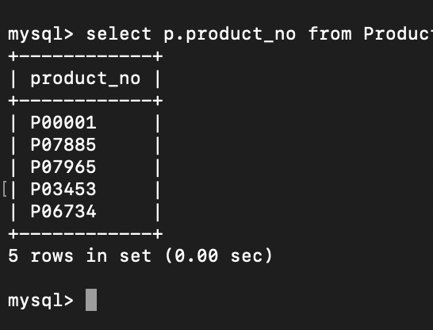

1. find the product_no and description of moving products.

**Query :** SELECT p.product_no, p.description FROM Product_master p, Sales_order s, Sales_order_details sd, Client_master c WHERE p.product_no = sd.product_no AND s.client_no = c.client_no AND s.s_order_no = sd.s_order_no AND sd.Qty_disp > 0;

# Output :

1

TSEC Batch:- S21 Name & Roll No:- Meet Raut, 2201084

**Database Management Systems Lab Experiment No: - 08 Aim: - Implement Joins and Nested SQL Queries**

1. find the names of the clients who have purchased 'CD Drive'.

**Query :** SELECT c.Name FROM Client_master c JOIN Sales_order s ON c.Client_no = s.Client_no AND Sales_order_details sd ON s.S_order_no = sd.S_order_no AND Product_master p ON sd.Product_no = p.Product_no WHERE p.Description = 'CD Drive’;

# Output :

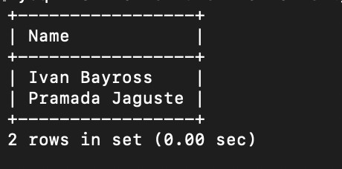

1. List the product_no and s_order_no of customers having qty_ordered less than 5 from the order detail Table for the product '1.44 Floppies'.

**Query :** SELECT sd.product_no, sd.s_order_no FROM Sales_order_details sd JOIN Product_master p ON sd.product_no = p.product_no JOIN Sales_order so ON sd.s_order_no = so.s_order_no JOIN Client_master c ON so.client_no = c.client_no WHERE p.Description = '1.44 Floppies' AND sd.Qty_ordered < 5;

# Output :

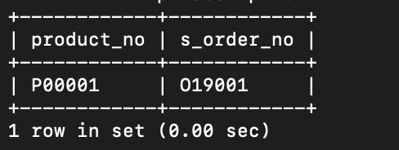

2

TSEC Batch:- S21 Name & Roll No:- Meet Raut, 2201084

**Database Management Systems Lab Experiment No: - 08 Aim: - Implement Joins and Nested SQL Queries**

1. Find the products and their quantities for the orders placed by 'Vandana Saitwal' and 'Ivan Bayross'.

**Query :** SELECT sd.product_no, sd.qty_ordered FROM Sales_order_details sd JOIN Sales_order so ON sd.s_order_no = so.s_order_no JOIN Client_master c ON so.client_no = c.client_no WHERE c.Name IN ('Vandana Saitwal', 'Ivan Bayross’);

# Output :

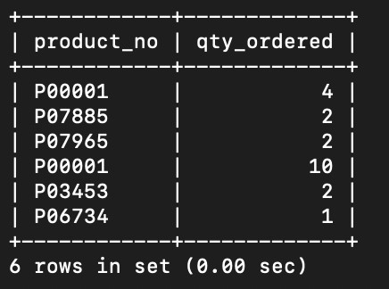

1. Find the products and their quantities for the orders placed by client_no'C00001' and 'C00002'.

**Query :** SELECT sd.product_no, sd.qty_ordered FROM Sales_order_details sd JOIN Sales_order so ON sd.s_order_no = so.s_order_no WHERE so.client_no IN ('C00001', ‘C00002');

# Output :

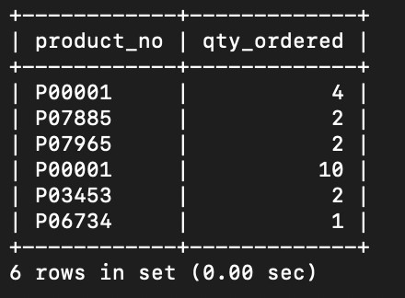

3

TSEC Batch:- S21 Name & Roll No:- Meet Raut, 2201084

**Database Management Systems Lab Experiment No: - 08 Aim: - Implement Joins and Nested SQL Queries**

# Nested Queries:-

1. Find the product_no and description of non-moving products (eg. products not being sold).

**Query :** SELECT product_no, description FROM Product_master WHERE product_no NOT IN (SELECT product_no FROM Sales_order_detail);

# Output :

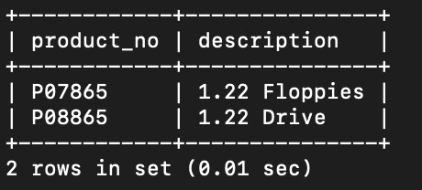

1. Find the customers name ,city and pincode for the client who has placed order no “O19001'.

**Query :** SELECT Name, City, Pincode FROM Client_master WHERE Client_no IN (SELECT client_no FROM Sales_order WHERE S_order_no = 'O19001' );

# Output :

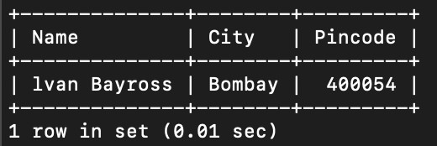

**Conclusion:-** LO mapped LO2,LO3.

4

TSEC Batch:- S21 Name & Roll No:- Meet Raut, 2201084